The Conversation Cottage
The Conversation Cottage is a practical informal tool that provides a big picture framework for the Conversation Coach to see the many areas involved with social language skills.
A Conversational Blueprint
GATE: Eye Contact and Social Intentions

PATH: Greetings, Chitchat, Conversations with embedded topics

STAIRS: Social language tools to stay in the longer conversations

PORCH: Perspective taking
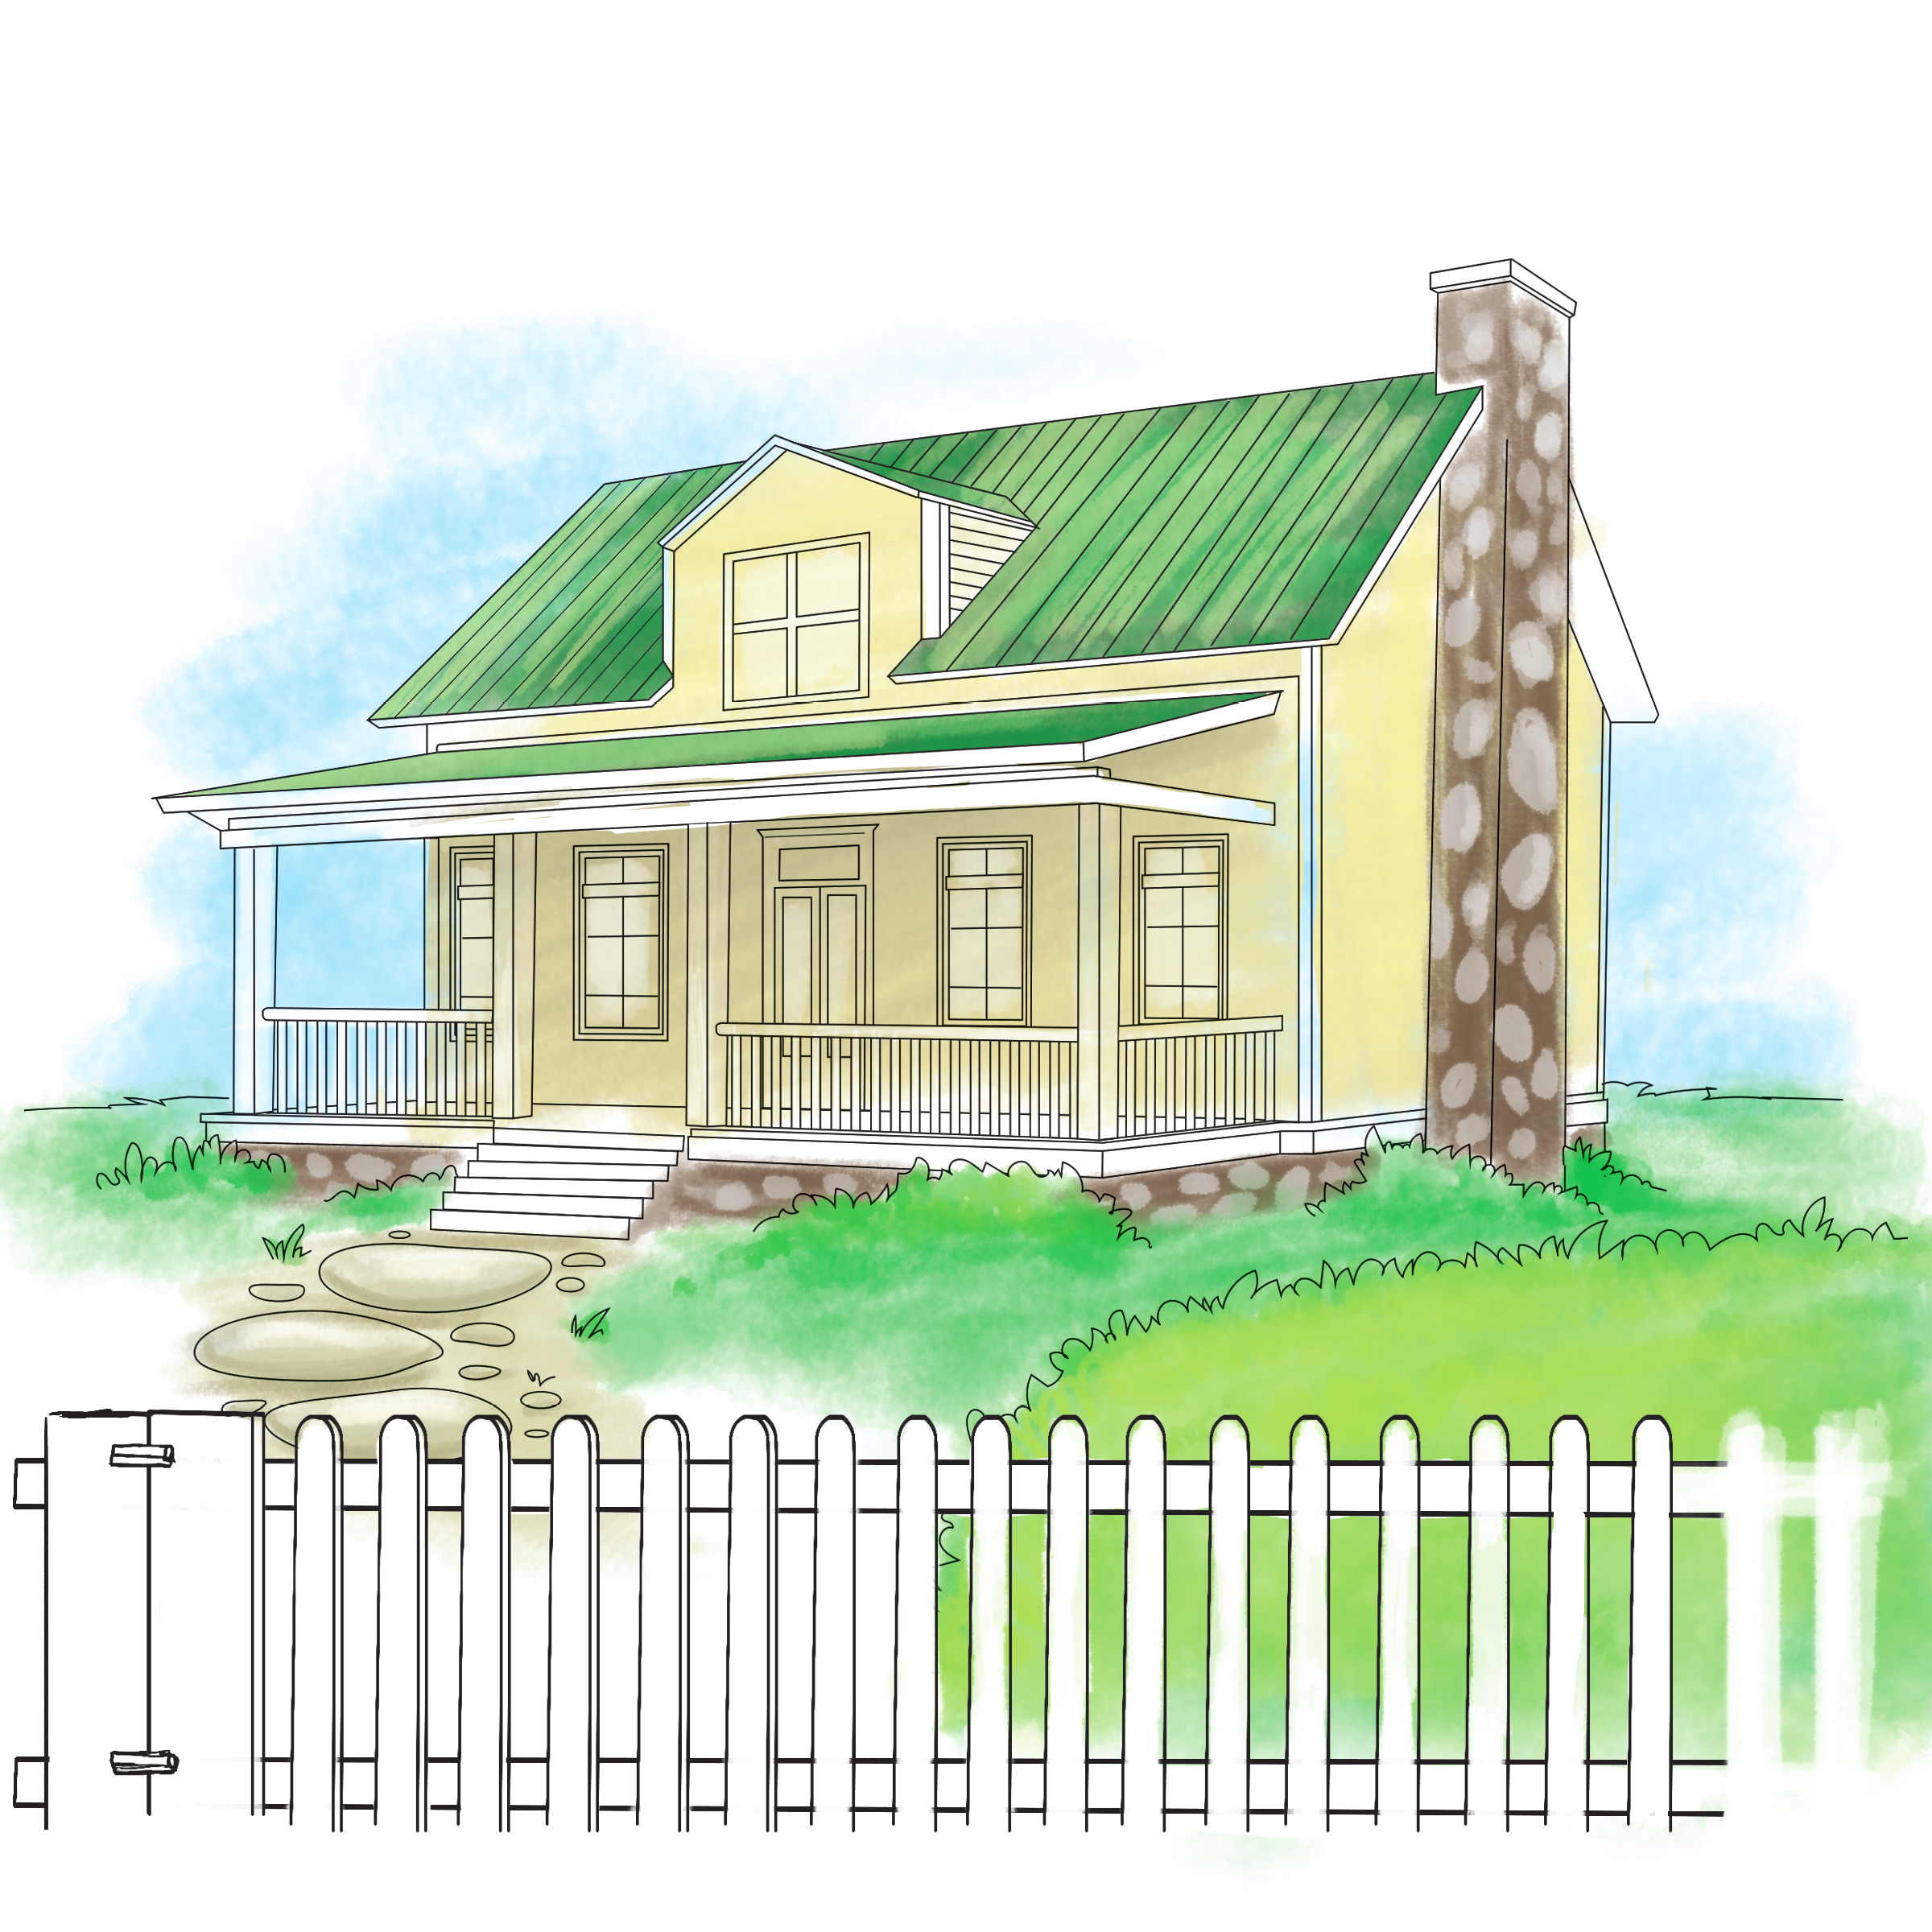
COTTAGE: Multiple skills working together to function as an adept conversationalist (i.e. vocabulary, grammar, syntax, problem solving, articulation, fluency, processing, memory, mental health, executive functions)
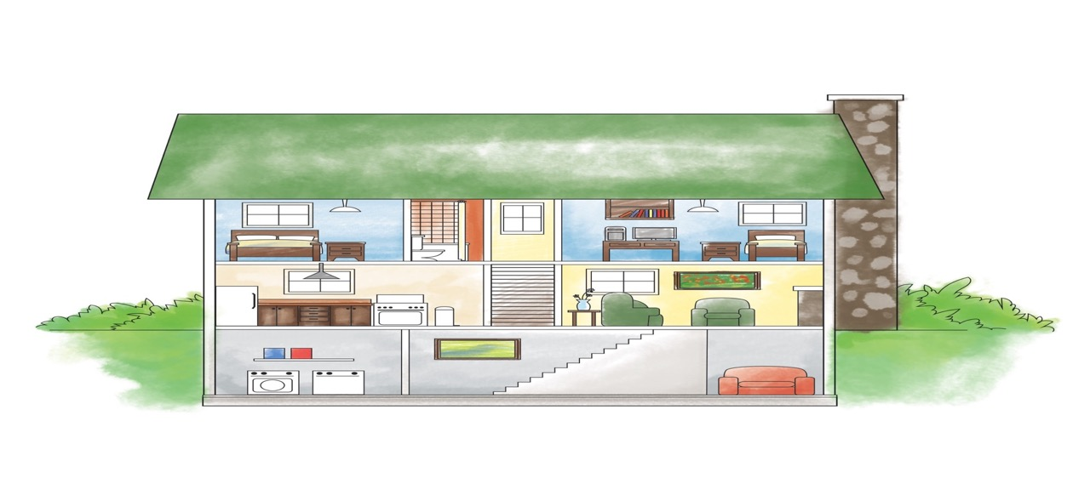

The Conversation Cottage can act as a Conversational Blueprint. It allows the Conversation Coach to get a quick snapshot look into the areas where an individual child is struggling; which may be of use when planning the intervention program.
Additional information about this teaching model can be made available upon request.

Delmonico 2014

