The Personal Profile Puzzle

As a Conversation Coach, we may all tend to approach our instruction from our own vantage point (i.e. life experiences, personalities, learning styles, educational backgrounds, philosophical preferences). However, it is in the better interest of the children when we take the time to consider where they are coming from in relation to their personalities, their learning styles and their social-emotional awareness, etc.

When we take the time to make good observations about our children, we can develop an individualized treatment plan that will best meet their needs. We can take a program that may be ‘good’, and make it ‘great’ because we have taken the time to consider their needs.

In so doing, there is a strong possibility that our children will then walk away from their lessons feeling like their perspectives - their preferences - their needs have been met!

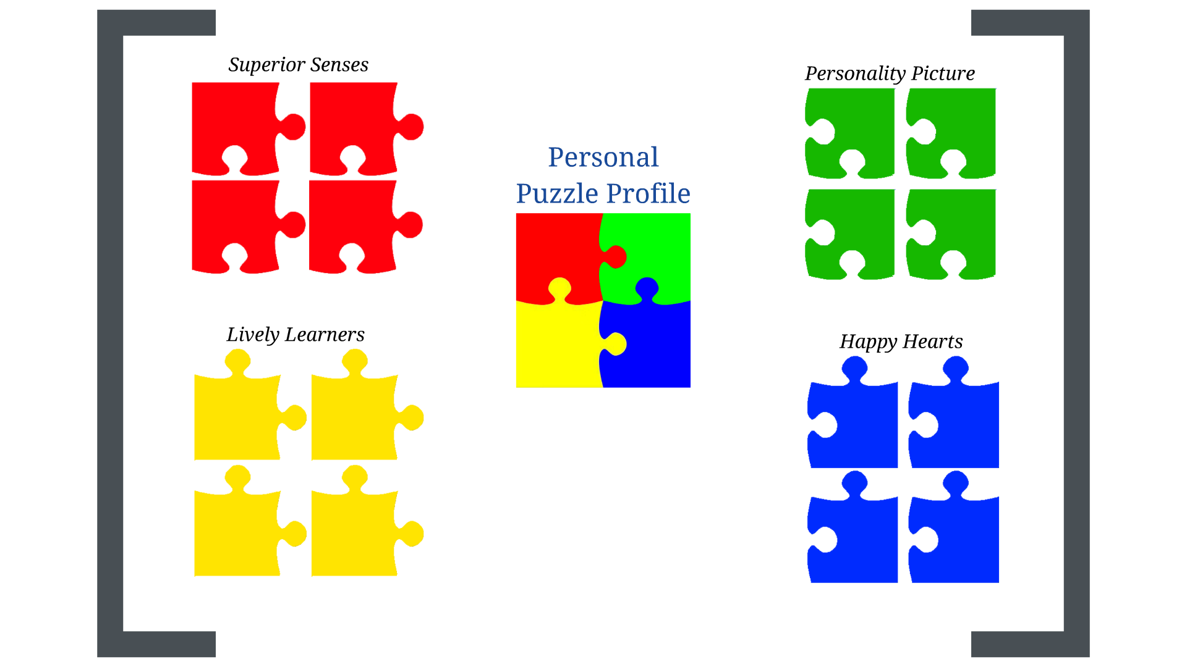

- SUPERIOR SENSES:
Provide a variety of activities - Think multi-sensory (i.e. auditory, visual, tactile, kinesthetic)

- PERSONALITY PLUS:
Adapt your interactions with children based on their motivation and comfort in engaging with others

- LIVELY LEARNERS:
Provide a combination of ideas, facts, small group activities and homework assignments

- HAPPY HEARTS:
Provide a variety of reinforcements (i.e. time, verbal praise, tangible rewards, etc.)

Additional information about this teaching model can be made available upon request.

Delmonico and Harder 2014

